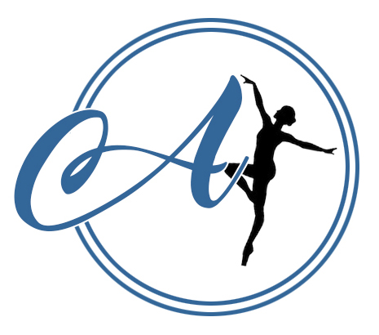
AVIAN DANCE SCHOOL RULES AND REGULATIONS

- Classes are invoiced for every half term with payment for the full half term expected. This can be paid via bank transfer or cash.
- Payment is expected within 2 weeks after receiving the invoice. You will receive the invoice 2 weeks prior to classes beginning. If payment is not made by this time, without contact, students will not be permitted to take part in the classes. Registers will be updated accordingly and only names on the registers will be allowed into class.
- We reserve the right to change our packages and will ensure to give the school a half terms notice.
- When paying by bank transfer, please use the invoice number as the reference. If paying by cash - please bring in a sealed envelope, labelled with your invoice number, student’s name, the date and amount enclosed.
- New students have a 28 day ‘trial period’ where they have the right to cancel without notice and receive a refund for unattended classes.
- As fees are paid a half term in advance, we ask for a half term’s notice if you no longer wish to attend classes and fees are payable during this period.
- We do not expect students to buy the school uniform in their first half term of classes, however they are welcome to do so. Uniform expectations for each class can be found in your confirmation email, or you can ask the Principals.
- Jewellery is not permitted during classes; this is a health and safety hazard. We will allow small studs to be worn in ears.
- Avian Dance School is not responsible for personal possessions that are damaged or lost during our classes.
- To avoid the hindrance of other student’s learning, disruptive and inappropriate behaviour will not be tolerated.
- Avian Dance School is committed to keeping customers up to date and does so via email, Social Media (mostly Facebook) and Whatsapp. We politely ask you provide us with up to date contact details. It is your responsibility to keep an eye on these forms of contact to avoid missing important information.
- All students must have a registration form filled in that includes physical corrections waiver and photography/videography before attending any of our classes.
- We ask that you please read through our policies and procedures, these can all be found on our website and are also printed and available to read at the studio.
- All data is held in accordance to our GDPR policy available on our website.
- Please see our Covid Policy for payments in regards to lockdown and isolation.

