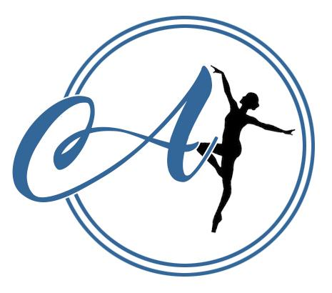
AVIAN DANCE SCHOOL RULES AND REGULATIONS

- Invoices will be sent 3 weeks before the next term of classes begins. This must be paid via bank transfer – we do not accept cash.
- Payment is expected, in full, 1 week before classes begin.
- A reminder will be automatically sent 1 weeks before payment is due.
- If payment is not made by this date, a £2.50 late payment fee will be immediately added to your bill. The late payment fee will be added every week that payment isn’t made.
- This admin fee policy applies to you even if you have asked to pay part of your bill by the deadline and the rest by another date after the deadline- full payment is needed by the deadline to avoid a late payment fee. NO EXCEPTIONS.
- If we do not receive payment and you have not made contact with us to discuss payment by the deadline- your space will be immediately given to someone on the waiting list.

- We do not offer refunds if you change your mind about attending classes.
- We do not permit you to attend another class in place of a missed class due to spaces being unavailable in other classes.
- If a class cannot be covered and we offer the same class a different week (such as in the half term holiday) this will then not be credited onto the following terms invoice.
- Should the studio cancel the class completely, we will credit your following invoice with the class missed. If you leave in this time, we will hold the credit on your account for if you return or take it off a one off workshop.
- We reserve the right to change our packages and will ensure to give the school a half terms notice.
- When paying by bank transfer, please use the invoice number as the reference.

- If you no longer wish to attend classes, cancellation of classes is expected before the next half terms invoice is sent.
- The last day you can cancel for the following half term is the day you receive your invoice.
- If you cancel after this day, then you will receive a late cancellation fee of 1 weeks worth of classes for your child.
- There will be no exception.

- We offer a ‘pay as you go’ trial week to decide if you would like to enrol in our classes.
- We do not expect students to buy the school uniform in their first half term of classes, however they are welcome to do so. Uniform expectations for each class can be found in your confirmation email, or you can ask the Principals.
- Jewellery is not permitted during classes; this is a health and safety hazard. We will allow small studs to be worn in ears.
- Avian Dance School is not responsible for personal possessions that are damaged or lost during our classes.
- To avoid the hindrance of other student’s learning, disruptive and inappropriate behaviour will not be tolerated.
- We do not tolerate any aggressive or inappropriate language or behaviour in our waiting area or towards our staff. We kindly ask if you have a concern or query to arrange a meeting with the teacher so we can talk it through with you.
- Avian Dance School is committed to keeping parents/guardians up to date and does so via email, Social Media (mostly Facebook) and Whatsapp.
- We politely ask you to provide us with up to date contact details. It is your responsibility to keep an eye on these forms of contact to avoid missing important information.
- All students must have a registration form filled in that includes physical corrections waiver and photography/videography before attending any of our classes.
- We ask that you please read through our policies and procedures, these can all be found on our website and are also printed and available to read at the studio.
- All data is held in accordance to our GDPR policy available on our website.

