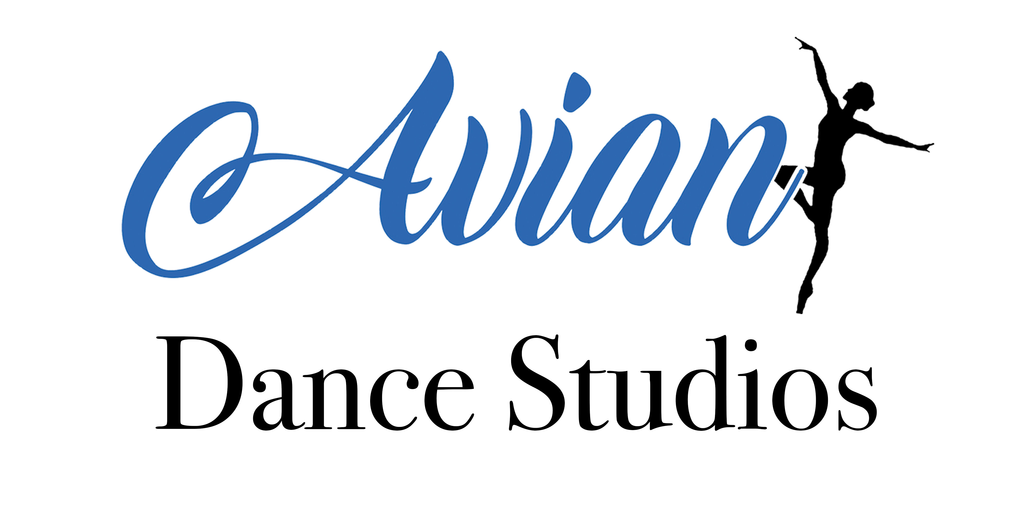

Studio Rules
COVID-19 Safe

- Please ensure you sanitise your hands when you enter reception and then again to enter the studio.
- Please ensure you sanitise your hands when you leave the studio to either use the toilets or collect your belongings.
- Any footwear that is likely to damage the studio floor is not to be worn. White soled shoes or dance shoes/bare feet only.
- No food or drink to be consumed inside the studio, with the exception of bottled water.
- Please do not enter the studio for your class until you are invited in.
- Please walk efficiently to your allocated box/es as directed by your teacher.
- Please keep doorways and hallways clear at all times.
- Please use the changing room facilities to store personal belongings and only bring essential equipment into the studio.
- Personal belongings are left at your own risk, Avian Dance School accepts no responsibility for lost or damaged items.
- Please be respectful of the areas you are using and make use of the bins available.
- Please be respectful and courteous of those around you by remembering this is predominantly an environment that nurtures the learning of children - inappropriate language or behaviour may result in being asked to leave the premises.

