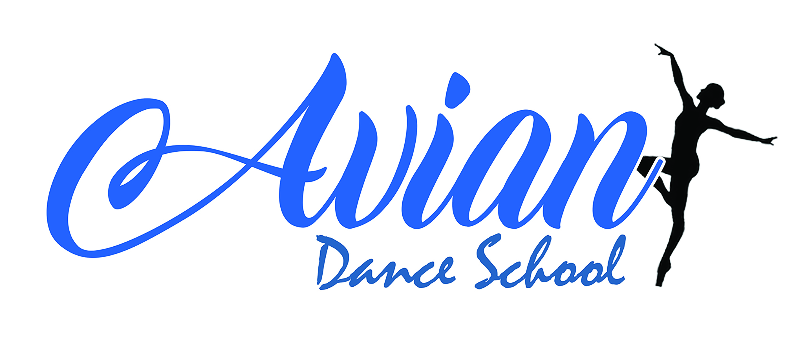

Avian Fire Evacuation Policy

Staff duty of care
Firstly, all staff members have a duty of care to take responsible steps to ensure the safety and welfare for themselves, students and visitors of the school to prevent risk and harm.
As teachers it is our responsibility to ensure all students and visitors of the school are made aware of the policy Avian Dance School / Avian Dance Studios has put in place.
This policy has been created for this purpose and should be followed accordingly.

Emergency Evacuation Plan
If you discover a fire:
- Raise the alarm immediately – There are smoke detectors located in both studios 1, 2 and every room in the building. There is a call point located by the front door also which can be activated by breaking the glass. Both systems will set off an alarm throughout the building.
- Evacuate – Please calmly walk through the fire exit door, this is our main entrance and exit to reception, leaving all belongings behind.
- Meeting point – Once you have exited the building, please wait in the car park at the front of Avian Dance Studios where you will be registered by a teacher or Principal.

If you hear the alarm:
Leave the building immediately –
- Teachers - Assemble students into single file to avoid blocking. Register folders should be taken with you, these are located on the table in each studio; belongings should be left behind. Teachers and students should then should calmly walk through the fire exit door, this is our main entrance and exit to reception. The meeting point is the car park at the front of Avian Dance Studios. A principal will do a final sweep of the building. Once outside at the meeting point, please use the register to tick off each student to make sure they are accounted for. If a student is not present, please make a principal aware. All registers should then be handed to a principal.
- Students – If you are in the studio with your teacher, please remain calm and listen to your teacher who will direct you safely out of the building.
If at the time you hear the alarm and you are not in the classroom with your teacher, please leave all belongings behind and make your way calmly to the fire exit which is our main entrance and exit door and wait at the meeting point which is the car park outside the front of the studios. You will be located by your teacher or principal and they will tick you off the register.
- Visitors/Parents – If when visiting the studio and you hear the fire alarm raised, please leave all belongings behind. Do not go looking for your child/children and make your way calmly to the fire exit which is our main entrance and exit door and wait at the meeting point which is the car park outside the front of the studios.
- Hirers – Assemble students/class into single file to avoid blocking. We advise having registers to hand in class to ensure you have everyone present; belongings should be left behind. Teachers and students should then should calmly walk through the fire exit door, this is our main entrance and exit to reception. The meeting point is the car park at the front of Avian Dance Studios. A principal will do a final sweep of the building. If a principal is not present, you must ensure the building is clear. Once outside, ensure all of your class/visitors are safely with you and please contact Principal, Harriet Wigger, immediately on 07584304521.

